**CHAPTER 1 :**

**INTRODUCTION**

# 1.1 BACKGROUND OF GOAPPS TECHNOLOGY SDN BHD

GoApps Technology Sdn. Bhd. is a Private Limited Company that was founded on October 10th, 2019. They have the knowledge and experience to put together ICT solutions that meet the majority of customer requirements. They seek to give the finest services possible by gaining a thorough grasp of the clients needs and maximising the use of ICT throughout the firm. GoApps is a company that specialises in creating digital solutions and applications for government agencies. They have ten years of expertise designing web-based asset management solutions for the government. As a result, customer engagement and experiences will improve. They achieve our company goal of being reasonably profitable so that they can continue to grow. Providing qualified customer support resources to their ever-growing portfolio and client database, as well as performing their services with integrity, excellence, and quality.

# 1.2 DEPARTMENTAL STRUCTURE OF GOAPPS TECHNOLOGY SDH. BHD.

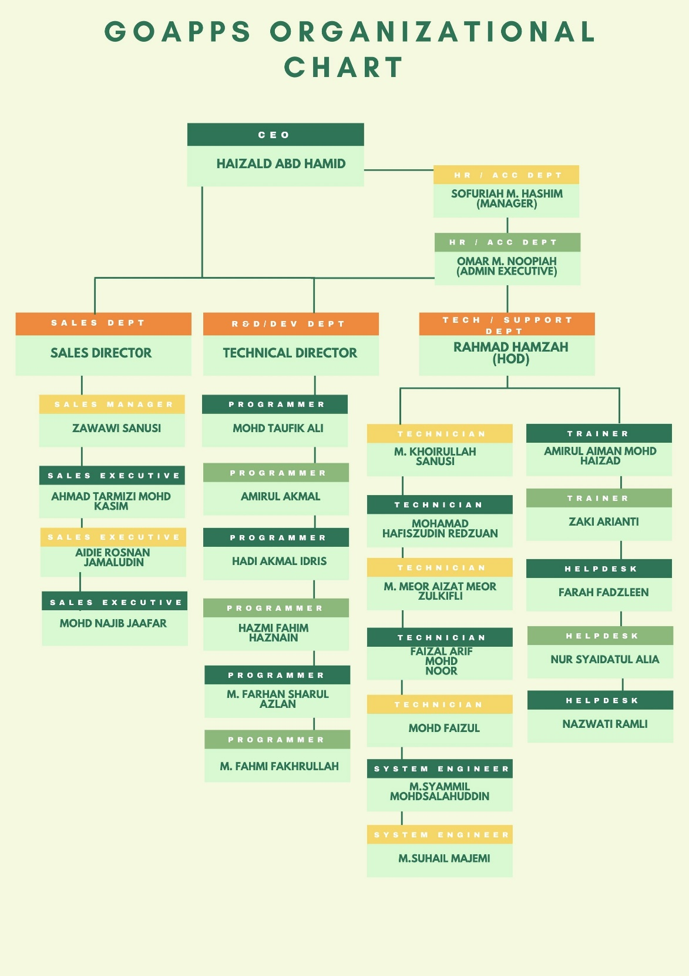

Figure 1 : Organizational chart of GoApps

**CHAPTER 2 :**

**ORGANIZATION INFORMATION**

# 2.1 GOAPPS TECHNOLOGY SDN. BHD. FUNCTION

* For fast, clean code, modern web development methodologies combine personalization of web design with compliance and responsive standards. Our web developers at GoApps use the most up-to-date technological tools, such as CSS, HTML5, jQuery, and current responsive design ideas.
* Development of mobile applications, responsive designs, and performance testing on smartphones, tablets, and desktops.
* Consultancy in information systems and technology. Focuses on helping businesses on how to best use information technology (IT) to achieve their goals.
* The goal of system integration is to improve the organization's productivity and quality of operations while also speeding up information flows and lowering operational costs.
* Hardware and software for computers and communications. A method of transferring data, instructions, and information between two or more computers or devices. The communications system is made up of cables and wires, as well as various computers and computing devices.
* To handle IT issues and maintain functionality connected to a given product or service, technical assistance and maintenance is required.

# 2.2 GOAPPS SDN BHD COLLECTIONS

Materials from Files Material and Digital Material are stored in GoApps. Minutes of meetings, reports, statistics, and other documents are among the files' contents. Client assets and the client's branding are included in the digital documents.

**CHAPTER 3: INDUSTRIAL TRAINING ACTIVITIES**

# 3.1 TRAINING ACTIVITIES

## 3.1.1 REVISION OF GOAPPS DATABASE

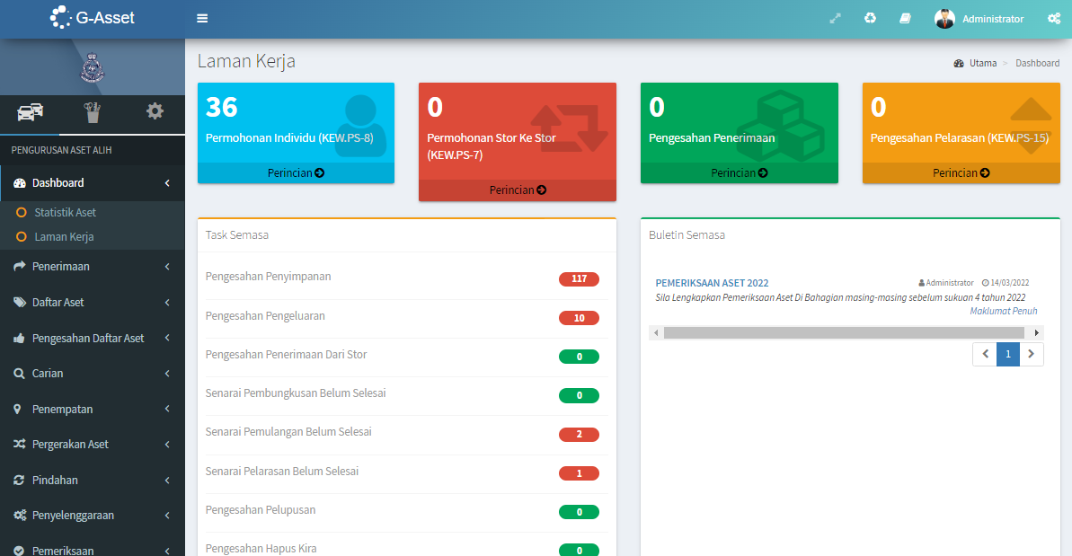

Figure 2 : one of GoApps clients database

The first task I was given was to discover how their database operates from the standpoint of a user. My guides have been Mr. Najib and Mr. Hazmi. Many of GoApps' customers are government agencies. SPAN, MBSA, PKNS, GiatMARA, and a slew of other acronyms come to mind. The GoApps database is divided into seven sections: G-Desk, G-Live, G-Exec, G-Asset, G-Store, and G-Intan. During this time, I learnt a lot about the database they're working on, including how users may register their companies' assets, locate their assets, track the last position of assets borrowed to whom, and dispose of assets correctly according to government circulars. The most important thing I learned throughout this training was how government forms are developed and the many types of forms. KEW.PA 3 and 4 are asset registration forms, for example.

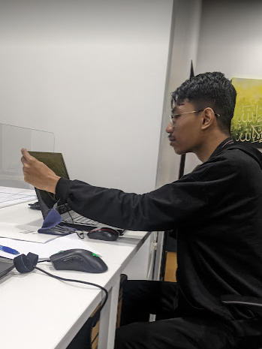

Figure 3 : I learn about GoApps Database

## 3.1.2 PREPARATION BEFORE GO TO USER ACCEPTANCE TEST (UAT)

The second assignment I have been given is to exhibit our database to clients in the Information Technology Departments of Majlis Bandaraya Shah Alam (MBSA) and Selangor State Development Corporation (PKNS). Mr. Amirul and Mr. Saipul were in charge of the project. User acceptance testing (UAT), also known as application testing or end-user testing, is a stage of software development in which the product is put to the test by its intended audience in the real world. Before the tested product is distributed to its intended market, UAT is frequently the last part of the software testing process.

The purpose of user acceptance testing (UAT) is to guarantee that software can handle real-world tasks and meet development standards. Users are given the opportunity to engage with software prior to its official release in UAT to determine if any features have been ignored or if any issues have been found. Mr Amirul and Mr Zanuri offered us a tutorial on our clients' database before we went to UAT. Not every client requires the GoApps database's seven sections. MBSA, for example, just needs G-Asset, G-Store, and G-Exec. During the UAT, we were given the task of writing down everything that the clients wanted changed or any database bugs. Clients must also fill out a form indicating whether or not they agree with the features. UAT usually takes two to three days to complete. After that, we will convert the form and notes into a report so the programmers may move on to the next phase. The last UAT normally occurs three to four weeks following the first UAT. Before the database can go live, the final UAT is to ensure that the client is satisfied with it and that there are no bugs.

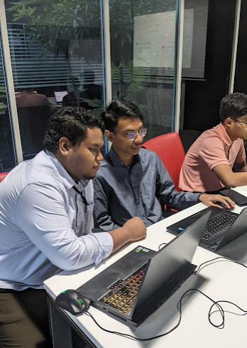

Figure 4 : Mr. Amirul aided me in understanding the client database

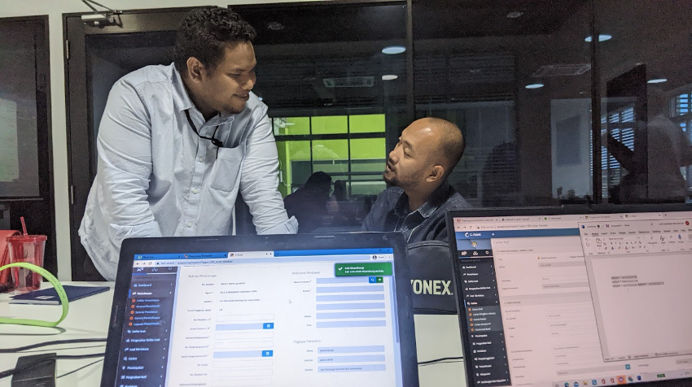

Figure 5 : Mr Amirul and Mr Zanuri discuss about clients database



Figure 6 : Example form that clients need to fill up

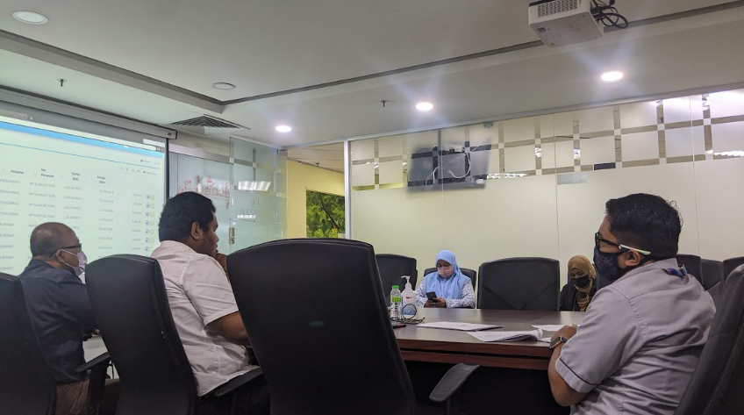

Figure 7 : UAT at MBSA with Mr Amirul and Mr Zaki

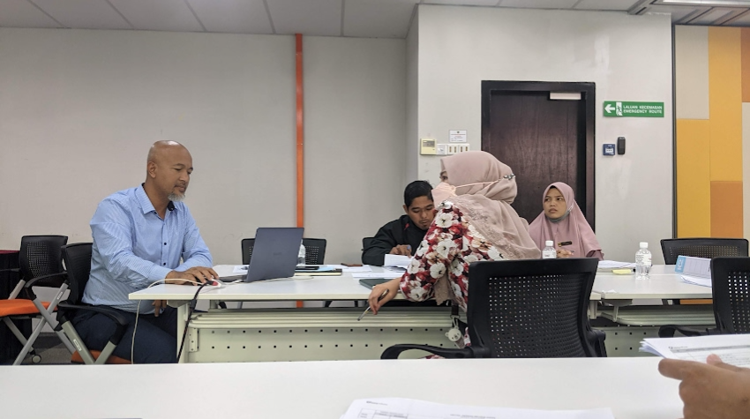

Figure 8 : UAT at PKNS with Mr Saipul

## 3.1.3 FINDING ERROR IN CLIENTS DATABASE

The next task that has been assigned to me is to locate any errors that may have been left in the clients database. Mr. Hazmi was in charge of the project. He wants me to detect any database flaws, such as erroneous data descriptions, statements, client logos in forms, or broken download buttons. Then I need to make a table and list all of the bugs so that all of the programmers know where they can resolve them.

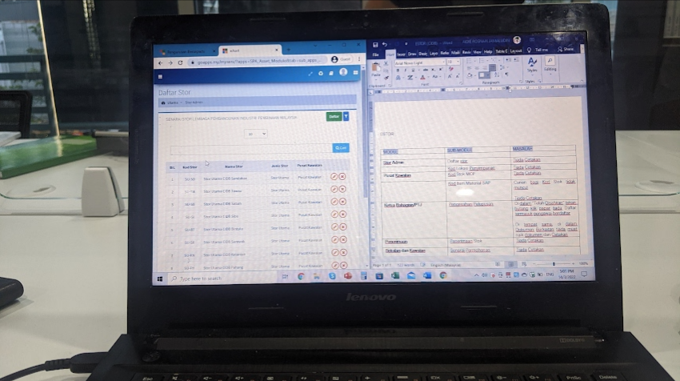

Figure 9 : Finding error in MBSA database

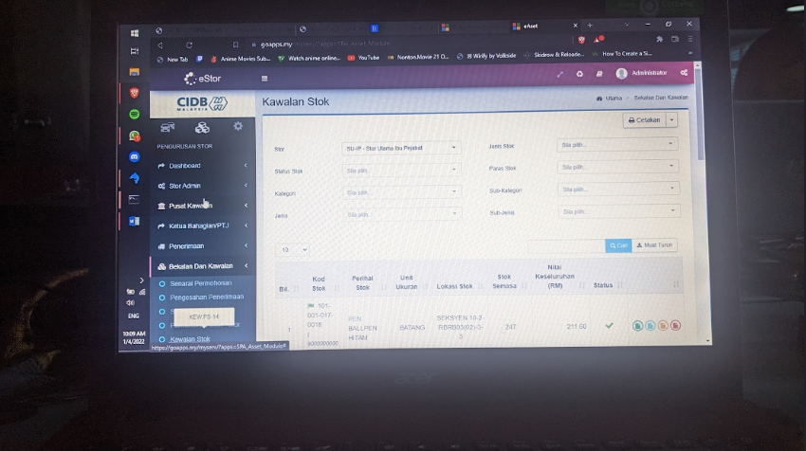

Figure 10 : Finding error in CIDB Database

## 3.1.4 FILL IN CLIENTS ASSETS IN MICROSOFT EXCEL

The fourth task is to fill in all of our client's movable and non-movable assets. Mr. Zaki was in charge of the work. I need to derive sorts of assets in Knowledgebase.gov.my because our client is a government agency. There are thousands of different sorts of assets that I need to define and fill out in Excel, including laptops, automobiles, computer components, buildings, and so on. Because one type of asset has multiple categories, I need to clearly clarify the assets. For example, there are 55 different types of tables at Knowledgebase.gov.my table section.I learned more about Microsoft Excel shortcut keys and the standard Excel format in Microsoft Excel for government organisations during this procedure.

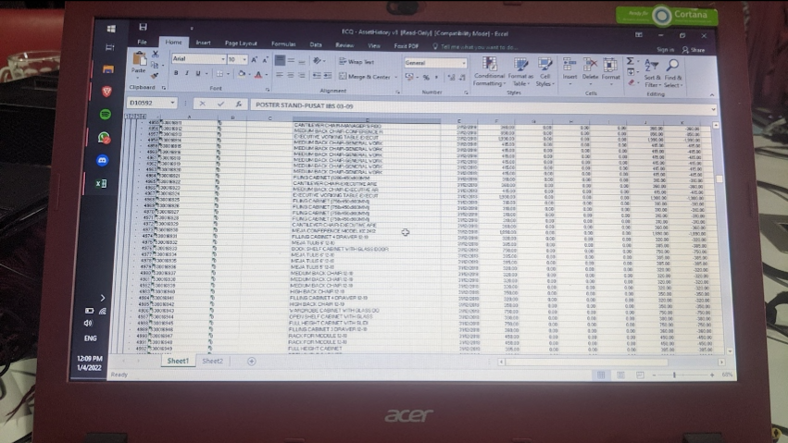

Figure 11 : Our client assets in Excel

## 3.1.5 LEARN AND INSTALL COLDFUSION 2016 AND MYSQLYOG

After that, I have been tasked to install Coldfusion 2016 that have been provided by company. This task have been supervised by Mr Hazmi, Mr Suhail and Mr Syammil. Before install Coldfusion 2016, Mr Hazmi explain about what is Coldfusion is. ColdFusion is a web programming language for connecting a web page to a database. It allows a programmer to quickly develop dynamic web pages that change based on user input, database lookups, time of day, or any other criteria. ColdFusion pages are made up of conventional HTML and CFML (ColdFusion Markup Language), such as "CFQUERY," "CFIF," and "CFLOOP." HTML 5, interactive charts and graphs, greater security, mobile website development, and increased performance are all included in ColdFusion 2016. A programmer can integrate an astounding range of functionality into a ColdFusion application that is not available in a static web page. It allows programmers to manage how our website behaves, integrate a database, and dynamically build the content that is returned to the web browser. SQLyog is a sophisticated tool for managing MySQL databases. It can also retrieve data quickly and export directly to Microsoft Excel. Aside from that, it is very keyboard friendly and can drop all tables in a database with a single click. With the keyboard, you can access 99 percent of SQLyog's capabilities. It take for me 1 days to install Coldfusion 2016 and MySQLyog rather than others who only takes 1 hours to 2 hours. During this training, I learned a lot of new stuff, including a new markup language and a new database. We're giving ourselves some time to learn the new language and database. I also have the opportunity to set up the Majlis Bandaraya Melaka Bersejarah database. It appears that CFML is similar to HTML in terms of ease of understanding. One of the differences is that when I begin coding in CFML, I must begin with <cfoutput> and continue with it.

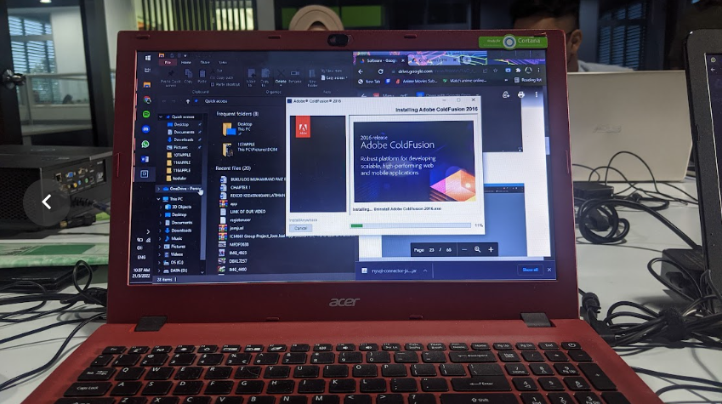

Figure 12 : Waiting for Coldfusion 2016 to install

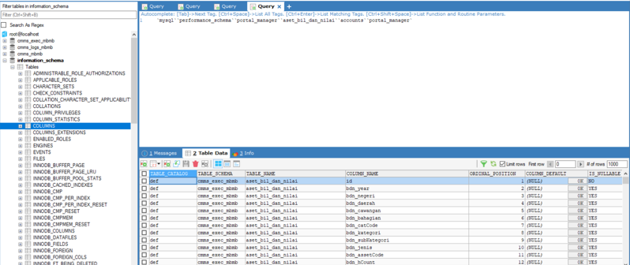

Figure 13 : one of MBMB database table

## 3.1.6 LEARN AND INSTALL JASPER REPORT

I need to install and learn about Jasper Report for the next task. Mr. Hazmi is the person in charge of this project. JasperReports is an open-source Java reporting engine. JasperReports is a Java class library for Java programmers who want to integrate reporting into their applications. This simple and easy-to-understand introduction covers practically all of the principles of JasperReports that a novice should know. Our organisation uses Jasper reports, according to Mr. Hazmi, because our databases can generate reports on every sub-module in every section. Because I am unfamiliar with government document formats, I only learned the basics regarding Jasper Report. There are 32 KEW.PA and KEW. PS

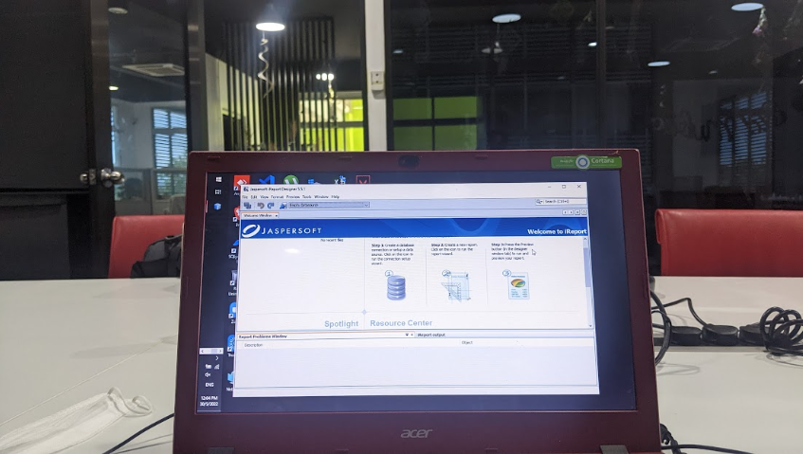

Figure 13 : User-Interface of Jasper Report

## 3.1.7 DOING SYSTEM REQUIREMENT SPECIFICATION FOR MBSA AND SPAN

Doing a System Requirement Specification (SRS) for government agencies is the eighth task I have been assigned. Mr Saipul and Mr Amirul are in charge of the work. They show me how to understand each field and its explanation, the many sorts of buttons, how to recognise if a button or input field can be edited, and the difference between obligatory and verification. All of this must be done in Malay and in accordance with official guidelines. They also show me how to correctly screenshot and crop what is in the clients database during this process. G-Exec sections have been assigned to me for both of these tasks. This task teach me on how to properly complete official paperwork.

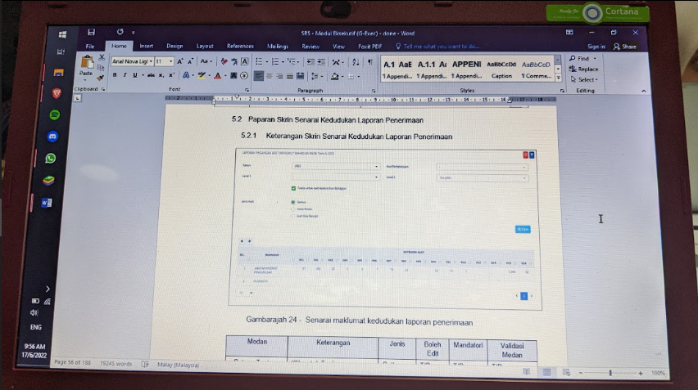

Figure 14 : System Requirement Specification for SPAN

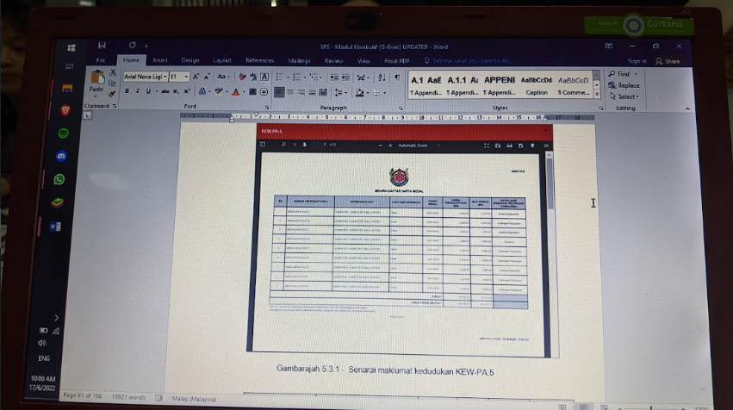

Figure 15 : System Requirement Specification for MBSA

## 3.1.8 LEARN COLDFUSION MARKUP LANGUAGE

I need to learn about ColdFusion Markup Language for the eighth task (CFML). Mr. Hazmi is the one who has been tasked with teaching me CFML. When an application is requested, the ColdFusion Markup Language (CFML) includes tags that define actions that are done on a ColdFusion server. CFML can be used to store database activities, embedded HTML, and other web page elements. Although it appears to be comparable to HTML, CFML must begin with <cfoutput> and has numerous tags that are unique to CFML. In CFML, he taught me how to make a simple front-end and back-end. I begin by creating the design and login functionality. He then showed me how to connect to a Coldfusion database and have it appear after logging in. Finally, he demonstrated how to construct an edit button in a site that I created. Afterwards he asked me and the other intern students to split up into two groups and develop one website with all of the functions he taught us. My team and I decided to create a gym database with subscription features. This has shown me how programmers work together as a team to solve problems.

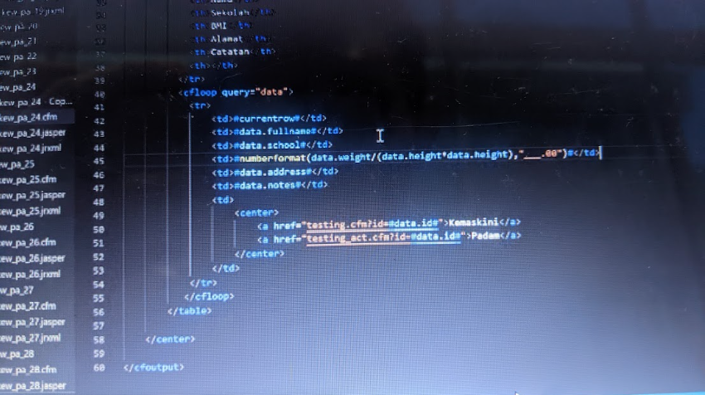

Figure 16 : System Requirement Specification for MBSA

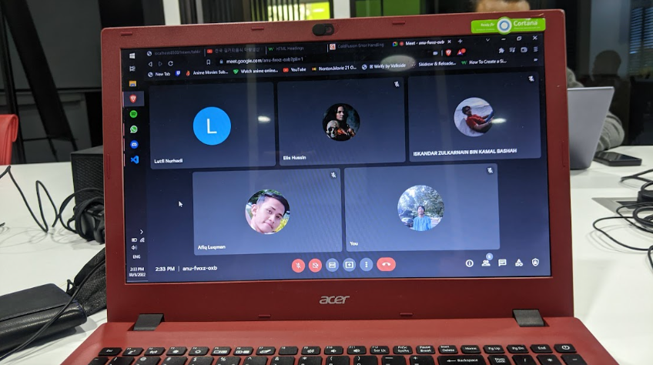

Figure 16 : Discuss with other intern students

## 3.1.9 LEARN AND DO PROGRESSIVE WEB APPS FOR COMPANY

My ninth task is to work with my supervisor and the other intern students on Progressive Web Apps (PWA). GoApps Sdn Bhd is working on a new project to replace their outdated mobile apps. Mr. Hazmi explains that a Progressive Web App (PWA) is a web app built using web technologies such as HTML, CSS, and JavaScript, but with the look and feel of a native app. Before we begin, we must sketch and create a mockup. We finally receive approval from the boss and senior programmer after several rejections and revisions. I was given the responsibility of creating an HTML valuation form for PWA. Even though it was a little difficult and I made a lot of mistakes in my coding, it was a fun time full of new information.

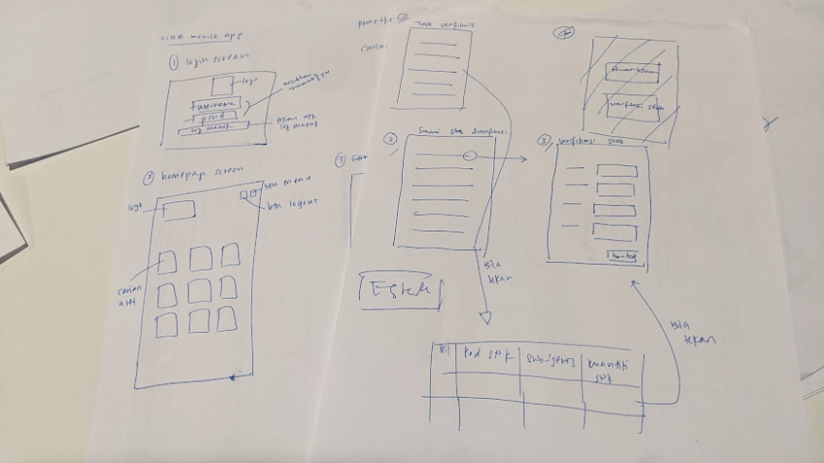

Figure 17 : sketches of our new PWA

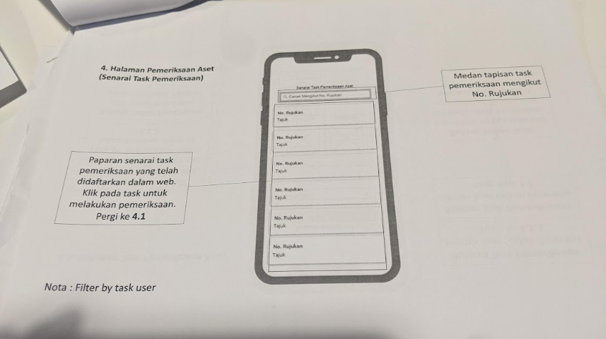

Figure 18 : Mockup that have been accepted

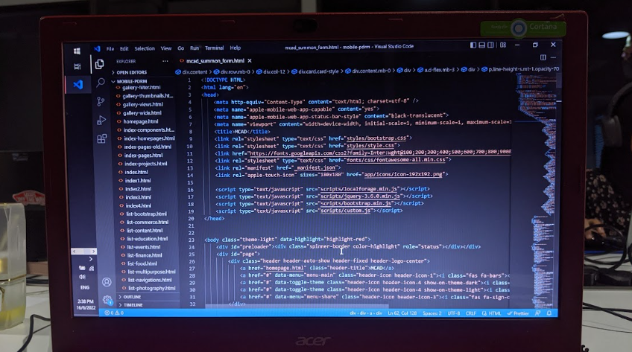

Figure 19 : HTML for Evalution form

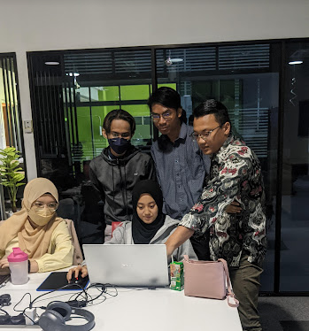

Figure 20 : Mr Hazmi explain where the mistake is

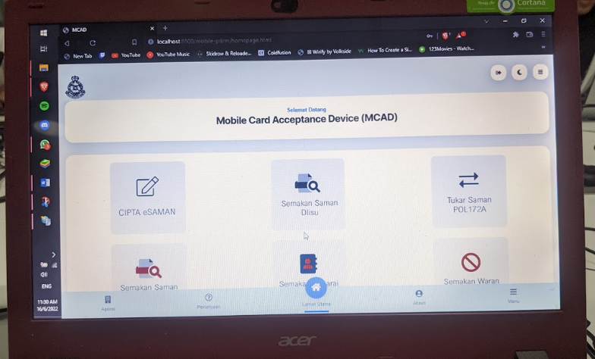

Figure 21 : Dummy PWA for GoApps that we have created

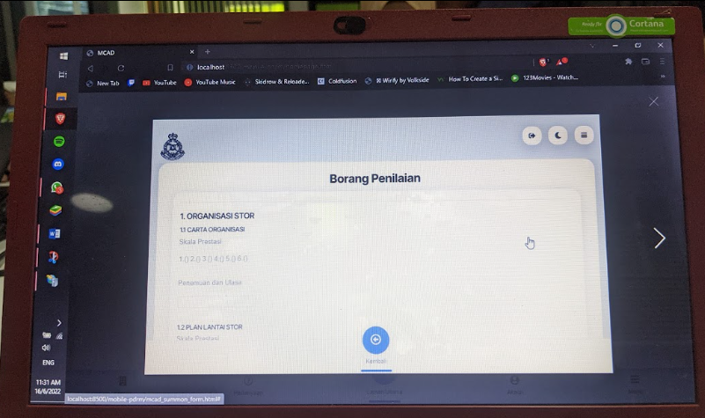

Figure 22 : Evaluation form that I create in PWA view

## 3.1.10 IDENTIFY AND FILL PRIMARY KEY AND FOREIGN KEY IN DATA DICTIONARY FOR SPAN

Mr Saipul is in charge of my tenth assignment. He wants me to find the SPAN database's Primary Key and Foreign Key, as well as fill in the SPAN data dictionary. In the data dictionary, there are hundreds of tables and thousands of keys. I need to write in Malay and in a government format. Because the database is active, I must proceed with caution. We learn something useful, such as how to tell which is the Primary Key and which is the Foreign Key in Coldfusion. During this procedure, I was offered the option to edit their database. Now I'm aware that there are numerous databases and methods for doing so.

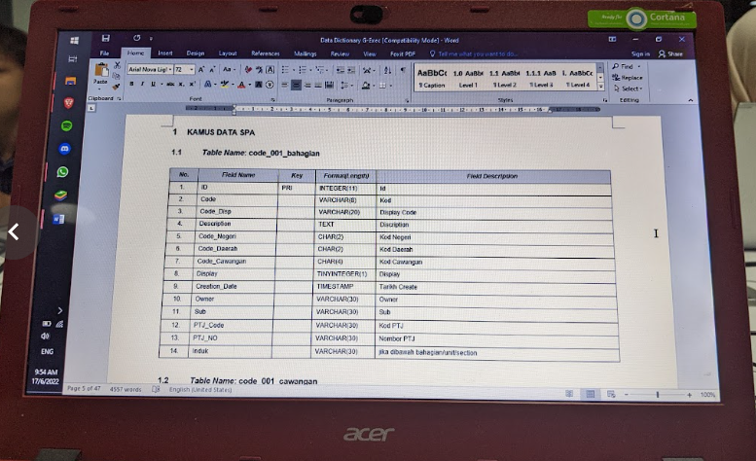

Figure 23 : One of the table I need to identify and fill in

# 3.2 SPECIAL PROJECT

## 3.2.1 PROJECT OVERVIEW

## 3.2.1 WEB OVERVIEW

**CHAPTER 4: INDUSTRIAL TRAINING REFLECTION**

# 4.1 APPLICATION OF KNOWLEDGE, SKILLS AND EXPERIENCE IN UNDERTAKING THE TASK (KNOWLEDGE GAINED)

From my internship experience at GoApps Sdn Bhd, I was able to firsthand experience the office working atmosphere, which is very significant because I have only worked as an intern student in the programing and documentation department, and this was my first of such experience. It is incredibly encouraging to be able to observe the work process, the dedication it entails, and the communication between coworkers and other internship students in order to accomplish a task before its due date.

Even though I am using all of the knowledge I learned in class, I still believe I am not doing enough for the firm because there is so much more I need to learn from them, such as Java, CFML, and HTML tags. Even if I am not as good as the other Computer Science Internship students, they continue to teach and explain the procedure to me till I comprehend it. As a result, I've been able to obtain additional programming experience, which will be beneficial to me in the future. It will bolster what I already have. I communicated with every department so that I could feel and understand how the work flowed there, and they, in turn, could understand the work of other departments since their work is intertwined. For example, a programmer must be able to comprehend standard government documents or reports, and going through all of this has made me realise how diverse working skills are, as some people are better at doing certain things than others, and it is critical that we use our specialties while also continuing to learn new skills in order to contribute to any organisation that we have joined or will join in the future.

There are occasions when interns are given the opportunity to accompany other coworkers as a trainers to teach government employee, such as at GiatMara Johor or Lembaga Pelabuhan Klang. Because my name was not chosen, I will miss out on seeing how the database and mobile apps will look when they go live. Even though I didn't get the chance, I was able to put all of the skills I learned at university and at work to good use by using HTML, CSS, PHP, and MySQL to finish it. It is difficult at first because I have to combine my college and work lives, but I have managed to overcome it. This is not just an assignment; I need to create a project that will benefit the company's employees while also adhering to the organization's vision and mission. There were many prototypes that I ended up abandoning because they were unsuitable for the project, so when I started working on it, I did so very carefully so that I could give the best that I could through this project.

Finally, I think it's great that while we were interning, we were considered the same as all other employees, and when it came to deadlines, my boss always gave me an extra day because he explained that we were learning and needed time to understand, which helped me to unconsciously divide the time that I had left and make a schedule so that the work that was assigned to me could be completed within the company's timeframe.

# 4.2 PERSONAL THOUGHTS AND OPINION

In my personal view, I am honoured to receive my internal training at GoApps Sdn Bhd, it has been an eye-opening journey for me to both of the private and public sectors. I am confident that these will be memories that I will remember for the rest of my life and. I’d like to express my gratitude to Mr. Saipul Bahri, the Ceo of the company along with Mr. Hazmi Fahim my supervisor, and the rest of the staff for their continuous support, time spent teaching me, and wise advice during the entirety of my internship.

I have gained a lot of new knowledge in the field that I am unfamiliar with over the course of my internship, which at first made it difficult for me to comprehend and implement in my daily routine at the company. However, over time, it has become part of the day to me, and I have been able to use these skills. I believe that I am now at least somewhat familiar with any coding languages that I have learned over the course of the internship that I may have forgotten or not learnt during my studies. I feel secure enough to discuss it with others outside the technology industry. As I mentioned earlier, I was treated like a regular employee, which I believe is excellent because if we had been treated with any kind of prejudice, I don't think the experience would have had such a significant influence on me personally.

While working here as an intern, I've had the chance to speak with employees from other departments to learn about and understand their jobs from their point of view. In addition to learning how to code, I've also participated in activities like explaining what I've done while at the company to the director, furthermore I developed skills like communication and self-discipline.

In a nutshell, it has occurred to me that I have seem to have the impression that GoApps Technology Sdn Bhd truly cares about their interns as they gave me not only staff-related duties but also shared some of their expertise with me and with this newly attained information, I will continue to use it and teach others about it in my future endeavours.

# 4.3 LESSON LEARNT

As someone who has no prior programming knowledge, GoApps Sdn Bhd has taught me a lot. Because the company works on numerous government projects where a single mistake might result in significant problems, I was able to observe how each department in an organization does a variety of tasks that complement one another very effectively.

**Team Cooperative**

Without collaboration, an organization cannot achieve its objectives. The value of collaboration between permanent employees and other internship students was made clear to me by my internship experience. I can state with confidence that if the teamwork is poor, the final output cannot possibly be good. I learned the value of teamwork and how it affects the department's and the company's success from this experience.

**Networking advantages**

I gained communication skills and relationship-building experience during my internship. I learned how to introduce myself, chat with public employees and GoApps employees about my interests, knowledge, and skills, as well as how to ask questions and get a better understanding of programming and paperwork skills not just in the co-working environment but also among others in the industry. Overall, this procedure assisted me in expanding my professional network and emphasised how crucial it is to establish these ties. Since LinkedIn is obviously a fantastic professional networking site, I also connected with the majority of them there.

**Knowing The Culture of the Workplace**

Every company or organization has its own culture, I discovered as a university student, and culture affects communication. It's important to watch others in order to understand how they connect and engage with their coworkers or assist them with projects and chores. I immediately discovered that asking for explanation anytime something is confusing to me or I don't understand is acceptable.

**Enthusiasm is Valuable**

As an intern, I learned how important it is to be excited about learning new things, open to asking for additional work, and interested to learn and ask questions. I will be able to help more and enjoy being a member of the team if I adopt this approach. Curious and enthusiastic individuals also get more out of their work as interns, which leads to numerous chances.

**How Crucial Effective Communication Are**

Success in a work environment depends on effective communication. I discovered that it's crucial to get in touch with my manager or supervisor by phone, email, or SMS if I have any problems or am unsure of how to complete a task. It is preferable to seek assistance and clarification as opposed to always acting as though you have comprehended what needs to be done. But I also discovered that you should Google anything you can. Being an effective communicator includes refraining from asking questions when there are already available answers. Remember that time is an important resource for everyone. An intern's productivity, efficiency, engagement, and growth will all benefit from strong communication.

**The Advantages of Accepting Criticism**

It's crucial to solicit and accept professional feedback. For the sake of the future and my ability to advance and succeed in my work, it is crucial that I make note of both the good and bad elements. I discovered that although getting or giving feedback can be challenging, doing so will have a big impact on my success and career moving forward.

# 4.4 LIMITATION AND RECOMMENDATION

## **4.4.1 SUPERVISORS ARE UNAWARE OF YOUR LACK OF EXPERIENCE**

My supervisor rarely provides much context when assigning tasks, especially those that are specifically linked to programming. He just gave me the basics of programming when it came to instruction, anticipating that I would learn more by doing some research. It's because some interns have computer science degrees and are familiar with how programming works. Since they have a lot of work that needs to be done, it takes me some time to ask them about programming. When I don't know how to do something, I usually approach other intern students for help or just leave the question unanswered and wait for them to ask.

## **4.4.2** LACK OF EXPERTISE IN PROGRAMMING DEPARTMENT

The programming department is obviously fantastic, but in reality, they are now suffering from a lack of expertise. When they are shorthanded, requests and problems will grow, which will eventually have an impact on their services. As a result, trainees recommended that GoApps open up more work opportunities, particularly for recent grads. Less challenges and problems will arise when staff numbers rise and there is adequate manpower.

## **4.4.3** RELOCATION

There might not be any nearby internships that fit my goals. In that situation, I would have to pay for a pricey relocation in order to secure the internship. Due to the challenge of finding accommodation, moving makes the internship a little more challenging. Meals and work attire can be expensive and are rarely covered by companies. I create a budget based on my income and the financial help I receive from my parents before accepting this internship.

## **4.4.4** NOT ENOUGH FEEDBACK

There should never be a sense of uncertainty among employees regarding their performance at work. Additionally, they shouldn't have to wait until after their evaluation to hear back. Due to the fact that not all of them are capable of handling bottom-up communication, trainees advise the GoApps team to find an appropriate channel. I require one that enables leaders to make open, public statements in a way that promotes comments and feedback.

**RECOMMENDATION**

To bring more fresh ideas and experience in their fields, particularly in programming, it is advised to hire more professionals in the same age range (22-29 years old). A almost everyone is now in their forties, and their mindset is somewhat out of date and irrelevant. Even some of them lose interest in doing work and wasting time watch YouTube and grow weary quickly. The challenges faced by future students through this industry training, who must acquire some knowledge in their profession, such as programming and documentation. This only are addressed with some ideas or activities.

The person in charge of supervising interns will have substantial experience dealing with students in industrial education. Because most students are confused and are unable to resolve problems. For example like the front-end coding or back-end coding on their own. Organizing additional social events might also help intern students feel more comfortable around permanent stuff.

**CONCLUSION**

# 5.0 CONCLUSION

In conclusion, this internship was really positive and enjoyable. I can say that working with the GoApps Company has taught me a lot. My work's technical components are undoubtedly imperfect and have room for improvement. I believe that the time I invest in research and learning is worthwhile and helps to find a suitable manner to fulfil my position in the organisation as someone who lacks professional experience in the information industry and programming area. I need to gain more information and experience as a novice in order to keep up with the most recent programming and technologies. I have learned a lot throughout these five months of industrial training. Experience is important since I am well-prepared for my future career. I am incredibly grateful that they allowed me to train alongside the greatest of the best.

After finishing this program, I believe that I will have a fresh perspective on the information and programming fields because they are so important to modern industry, especially in Malaysia. Exposure to the real world of work is great for me since it helps me get used to the setting before I start working somewhere.

Last but not least, I gained knowledge of time management techniques and the need of self-motivation. All the experiences and memories I have gathered will accompany me as I go about living my life; I am confident that this will be to my great advantage and benefit.

**REFERENCES**

* GoApps Technology sdn bhd. (n.d.). Retrieved June 23, 2022, from https://goapps.my/gopro/

**APPENDICES**